Annexure –I

**STUDENT PROJECT PROPOSAL**

|  |  |  |
| --- | --- | --- |
| 1. | Name of the Student (s) V | : Anushharan DJ, Raghul R, Nithishkumar A, Sornalakshmi |
| 2. | one valid e-mail id | : anush20051999@gmail.com |
| 3. | Name of the Guide | : Mrs. Bharathi R |
| 4. | Department / Designation | : Department of IT / Associate Professor |
|  | Institutional Address (Autonomous) | : M.Kumarasamy College of Engineering |

Phone No. & Mobile No : 97867 83241

|  |  |  |
| --- | --- | --- |
| **5.** | Project Title | : **“SMART CROP PROTECTION SYSTEM”** |
| 6. | Sector in which your  Project proposal is to be Considered | : **Agriculture** |
| 7. | Project Details | : Attached as Annexure -II |

8. Has a similar project been carried: No out in your college / elsewhere? If so furnish details of the previous project and highlight the improvements suggested in

the present one

**CERTIFICATE**

This is to certify that Mr.DJ.Anushharan(19BIT4301), Mr.A.Nithishkumar(19BIT4064), Mr.R.Raghul (19BIT4074) and Ms.V.Sornalakshmi (19BIT4095) are the Bonafide final year students of U.G. Engineering course of our college and it is also certified that two copies of utilization certificate and final report along with seminar paper will be sent to the Council after completion of the project by the end of April 2023.

# Signature of the Guide Signature of the HOD Signature of the Principal/

**Head of the Institution**

# Annexure -II

## INTRODUCTION ///

The Smart protection system defines that this project help to farmer for the protection of a farm. We have designed this project for the only secure from animals but we this project have the provision to secure from the human begins also. This can achieve by the help of IOT device that we are discuss in this paper. The SCPS work on the battery so that this project can be easily portable and also we are add solar panels and converter modules this can help the battery to charge from solar energy. The IOT device is used to indicate the farmer by a message while someone enter into the farm and we are used SD card module that helps to store a specified sound to fear the animal.

## OBJECTIVE ///

This project defines the methodology used in the smart crop protection system. The purpose of SCPS is to secure or protect the farm from the theft in the farm or main purpose of this project is to alert the farmer as well as fear the animals with getting harm to animals.

### PROBLEM STATEMENT ///

It will help to farmers for the protection to farm and helps to secure from birds and human beings.

### METHODOLOGY ///

This project is smart crop protection system for protect the farm from animals as well as unknown person. This projects contents Arduino UNO, Rectifier, LCD display, Motion sensor, GSM Modem, Sd card module, Buzzer charges converter. This whole project is work on 12v dc supply from battery. We used solar panel to charge the battery. The other components used are as follows.

1.Arduino UNO

1. Rectifier
2. LCD display
3. Regulator
4. Motion sensor
5. SD card Module
6. GSM Modem
7. Buzzer

## WORKFLOW DIAGRAM

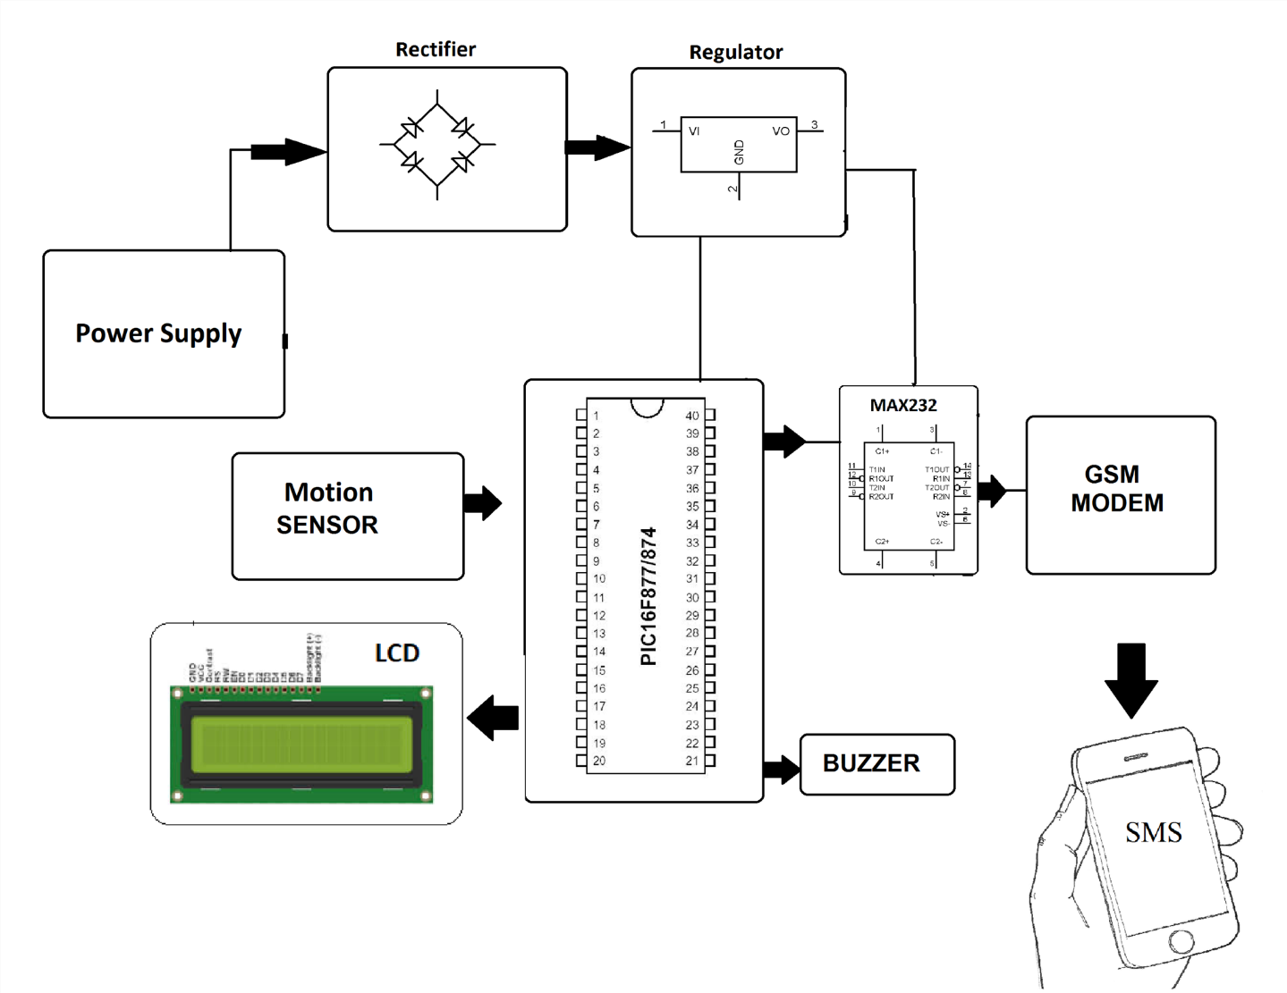

### FEASIBILITY STUDY

Feasibility study is used to analyze the feasibility of the project modules and

database. It checks the working of those attributes with regard to the requirements of the user. ➢ Database Tables

➢ Modules

### MODULES: ///

* Registration Page
* Login Page
* Upload Image page
* Prediction results page for food items
* View history of items

### DATABASE: ///

Create the IBM Db2 service in the IBM cloud and connect the python code with DB.

**ADVANTAGES:**

➨It allows farmers to maximize yields using minimum resources such as water, fertilizers, seeds etc.

➨Solar powered and mobile operated pumps save cost of electricity.

➨Smart agriculture use drones and robots which helps in many ways. These improves data collection process and helps in wireless monitoring and control.

➨It is cost effective method.

➨It delivers high quality crop production.

### HARDWARE AND SOFTWARE REQUIREMENTS

* Python
* Docker, Kubernetes
* Windows 64-bit
* Memory of 4 GB RAM
* Flask

### WORKPLAN

|  |  |  |
| --- | --- | --- |
| **S.NO** | **Plan** | **Date** |
| 1 | Requirements Gathering and Designing of  Modules | 01.09.21 – 30.09.21 |
| 2 | Module Development and availability  Checking | 01.10.21 – 30.10.21 |
| 3 | Module for Originality Checking | 01.11.21 – 31.12.21 |
| 4 | Result and Discussion | 02.01.22 – 16.01.22 |
| 5 | First Demo | 20.01.22 |
| 6 | End Product Demo | 22.02.22 |
| 7 | Project Document Preparation | 02.03.22 |
| 8 | Document Submission to TNSCST Office | 13.04.22 |

### BUDGET

|  |  |  |
| --- | --- | --- |
| **S.NO** | **Particulars** | **Amount** |
| 1 | Consumables | 5500 |
| 2 | Equipment Cost | 2500 |
| 3 | Contingencies | 1000 |
| 4 | Travel Cost | 700 |
| 5 | Other Cost | 400 |
|  | **Total** | 10,300 |